**1: How to import multiple files to a document?**

In this application you can import multiple files into a document.

For Example, Please see the following pictures.



In the above picture Document No. is “PI-179” and we imported the first data file. You can see the message also “1 File imported”.



In the above picture Document No. is “PI-179” and we imported the second data file. You can see the message also “2 Files imported”.



In the above picture Document No. is “PI-179” and we imported the 10th data file. You can see the message also “10 Files imported”.

**2: How to open multiple documents at the same time?**

In this application you can open multiple documents at the same time. For that you need to open new PI worksheet and click minimize button then open another worksheet.

Please see the below pictures.

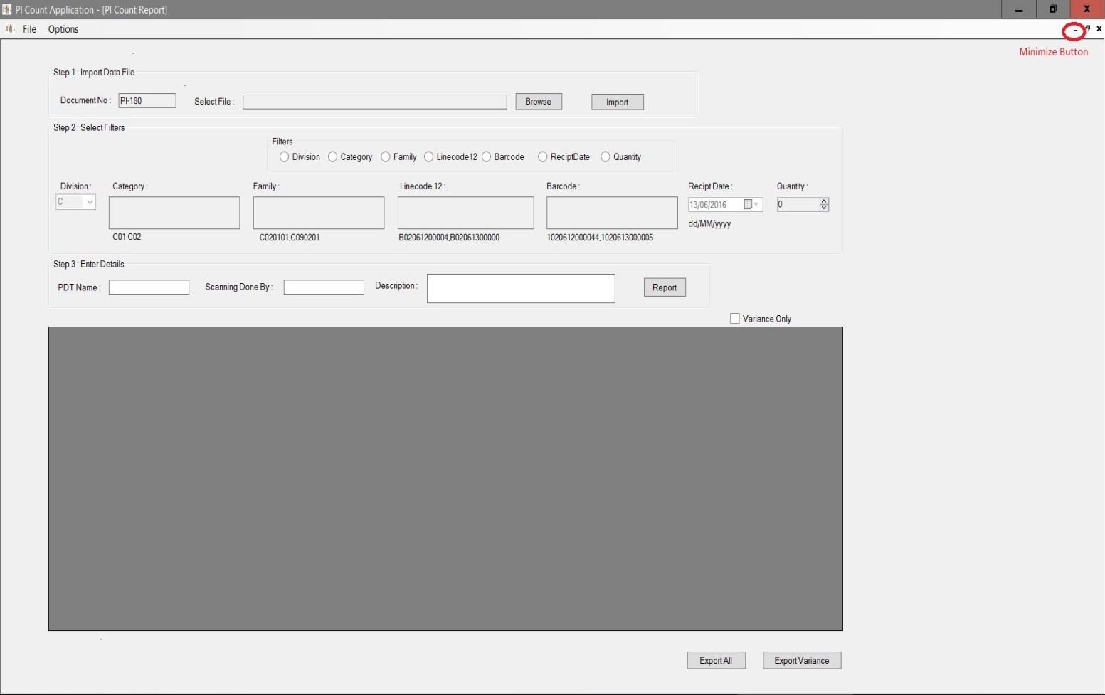

This is document no. “PI-180”.If you minimize this form then you can see all other opened documents.



Here you can see three documents (PI-180, PI-181&PI-182) and if you need to view one of them, just click on maximize button.

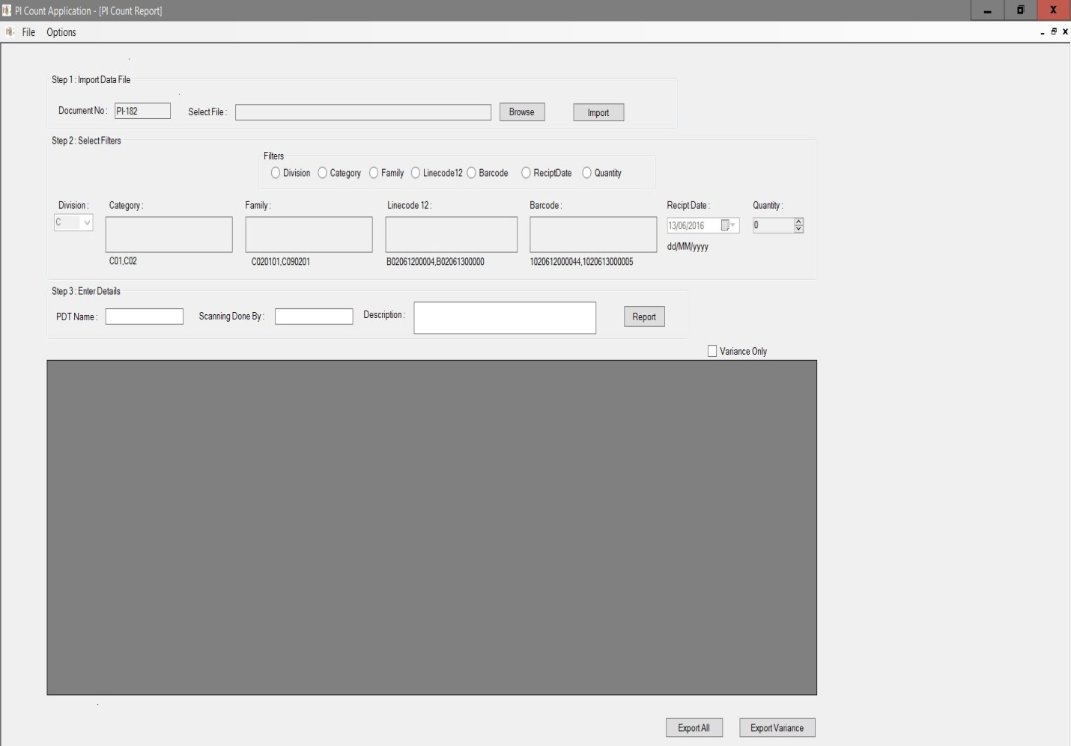

This is document No:PI-182